SonarQube Tool Installation & Configuration

First, download SonarQube version you want as per your requirement from – [www.sonarqube.org/downloads/](http://www.sonarqube.org/downloads/) shown below -

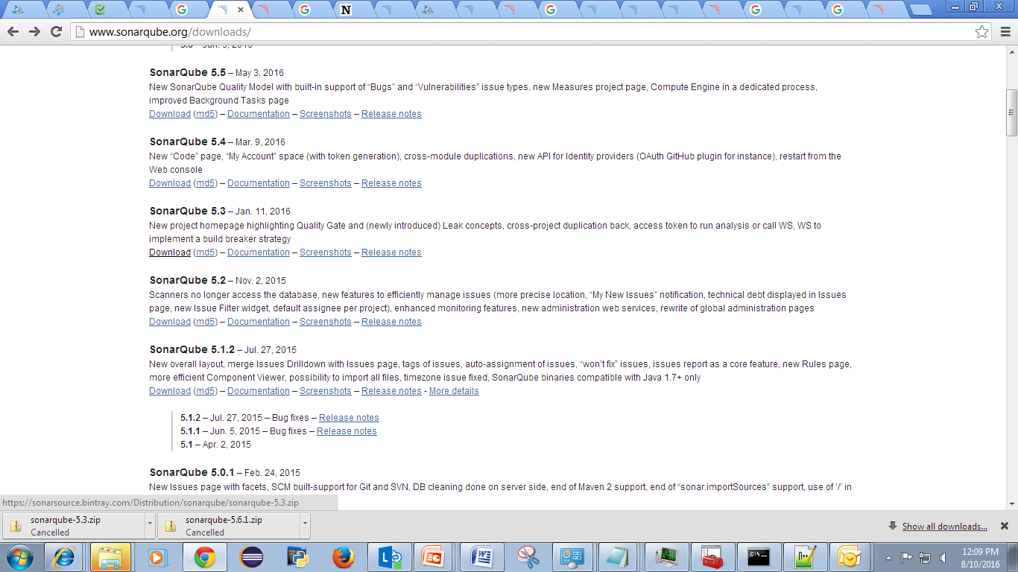

* Download SonarQube Scanner –

**SonarQube Scanner** is recommended as the default launcher to analyze a project with SonarQube.

Next, we have to download SonarQube scanner or runner for SonarQube from the link given below -

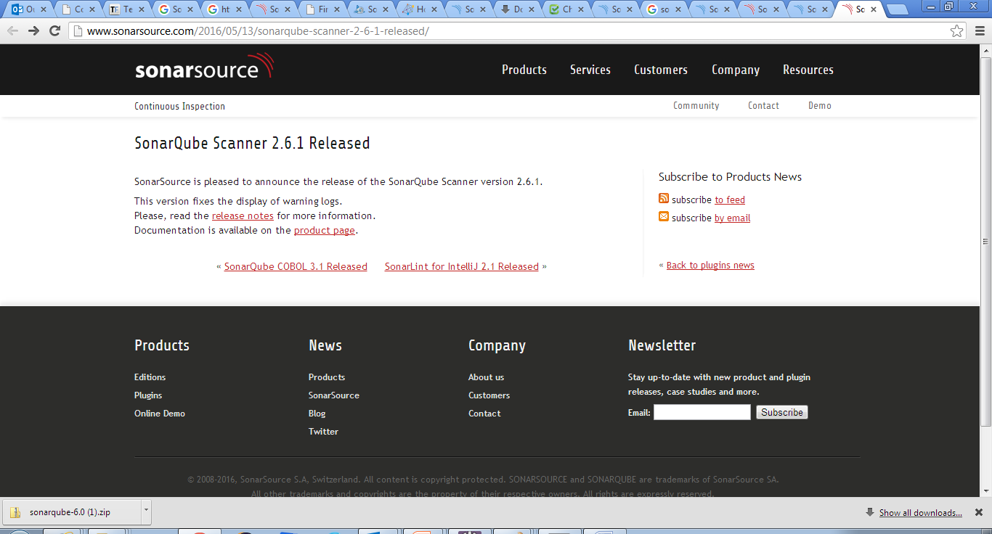

* Extracting zipped file of SonarQube :

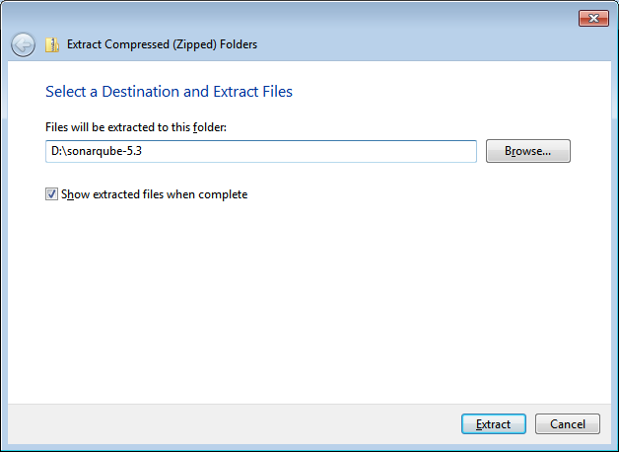

* Placing extracted file :

We will refer to it as <install directory> in the next steps.

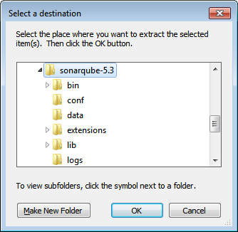

Update the global settings to point to your SonarQube server by editing <install directory>/conf/sonar-scanner.properties :

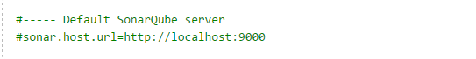

* We need to set the environment properties:

D:\sonarqube-5.3\sonar-scanner-2.6.1\bin

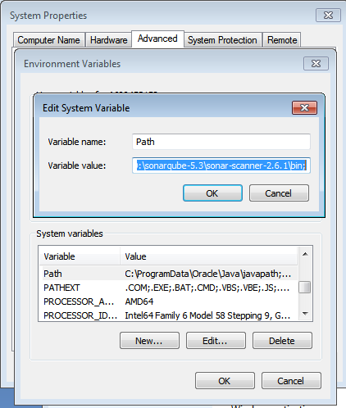

* Go to the location of your SonarQube and run StartSonar.bat in command prompt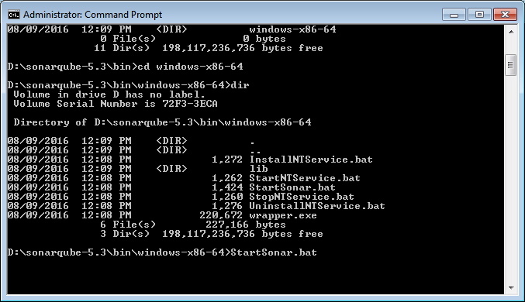

You can verify your installation of sonar scanner by opening a new shell and executing the command sonar-scanner –h

 (On Windows platform, the command is sonar-scanner.bat -h). You should get output like this:

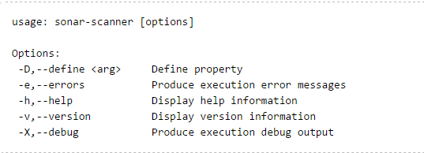

* URL to access:[**http://localhost:9000/**](http://localhost:9000/)

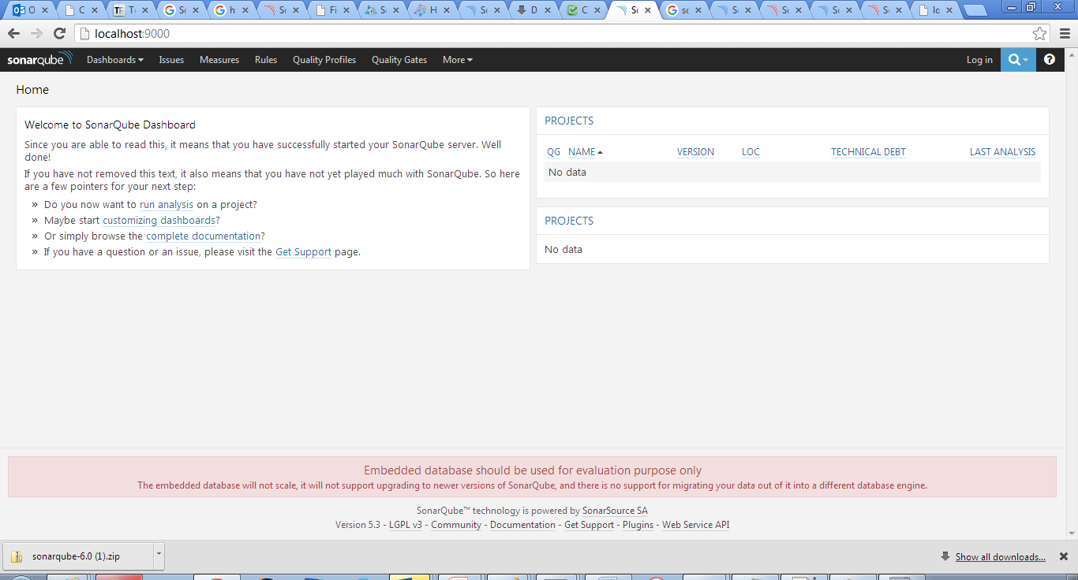

------------------------------------------------------------------------------------

To do code analysis using SonarQube in JENKINS:

1. You have to install “SonarQube Plugin” available in Jenkins along with the dependency plugins. Go to Jenkins 🡪Manage Jenkins 🡪Search in “Available”.

2. After that download sonar runner for that version of SonarQube

<http://docs.sonarqube.org/display/SONARQUBE51/Installing+and+Configuring+SonarQube+Runner> – Download link for SonarQube runner installation

3. After installation of the plugin, restart the Jenkins by the URL –

<http://localhost/restart>

4. If that doesn’t work means still you didn’t get the option of “Execute sonar scanner or runner” then download the .hpi file and upload the plugin in Jenkins

<https://wiki.jenkins-ci.org/display/JENKINS/SonarQube+plugin> – link for download the .hpi link for the sonar plugin

Configure your SonarQube server(s) in Jenkins:-

1. Log into Jenkins as an administrator and go to **Manage Jenkins > Configure System**:
2. Scroll down to the **SonarQube configuration** section, click on **Add SonarQube**, and add the values you're prompted for.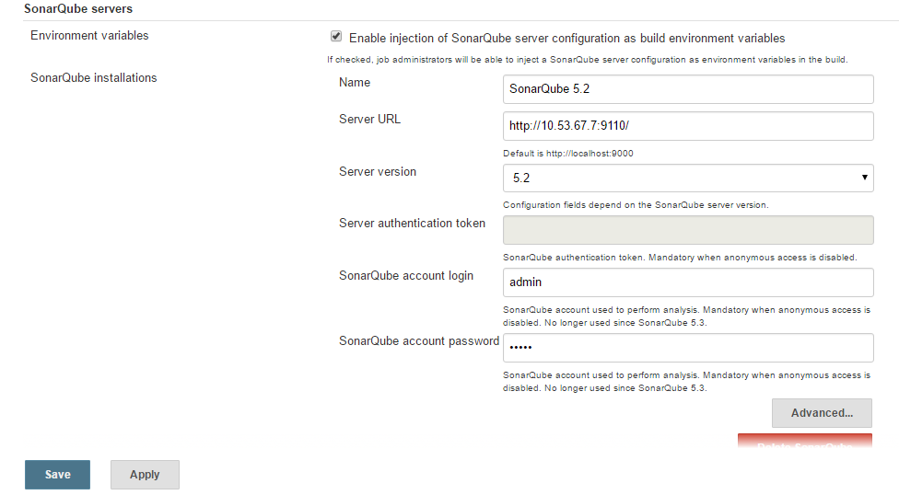

### **Global Configuration :-**

This step is mandatory if you want to trigger any of your SonarQube analyses with the [SonarQube Scanner](https://docs.sonarqube.org/display/SCAN/Analyzing+with+SonarQube+Scanner+for+Jenkins#AnalyzingwithSonarQubeScannerforJenkins-TriggeringaSonarAnalysiswiththeSonarRunner). You can define as many scanner instances as you wish. Then for each Jenkins job, you will be able to choose with which launcher to use to run the SonarQube analysis.

1. Log into Jenkins as an administrator and go to **Manage Jenkins > Global Tool Configuration**
2. Scroll down to the **SonarQube Scanner** configuration section and click on **Add SonarQube Scanner** and tell Jenkins to grab the installer from a remote location (check 'Install automatically'):

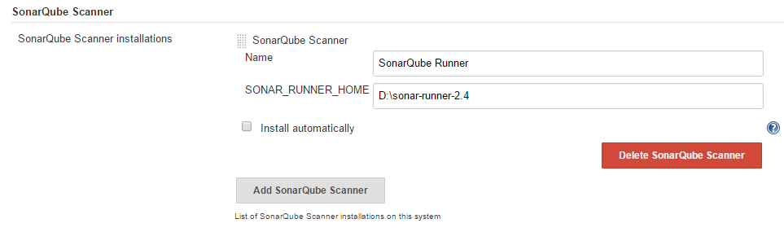



### **Jenkins Job Configure:**

1. **Configure** the project, and scroll down to the **Build** section.
2. Add the SonarQube Scanner build step to your build as shown below –

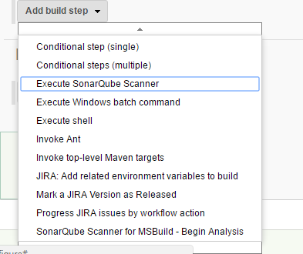

1. Configure the SonarQube analysis properties. You can either point to an existing *sonar-project.properties* file or set the analysis properties directly in the *Analysis properties*field as shown below -

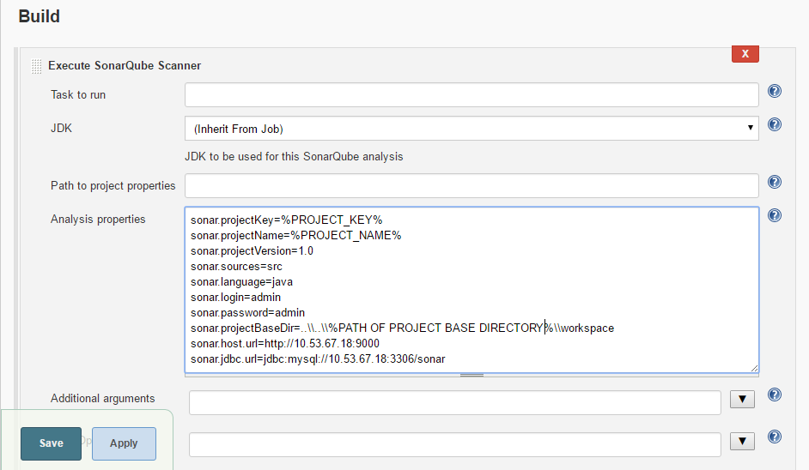

Analyzing with SonarQube Scanner for MSBuild

### Global Configuration

This step is mandatory if you want to trigger any of your analyses with the [SonarQube Scanner for MSBuild](https://docs.sonarqube.org/display/SCAN/Analyzing+with+SonarQube+Scanner+for+MSBuild). You can define as many scanner instances as you wish. Then for each Jenkins job, you will be able to choose with which launcher to use to run the SonarQube analysis.

1. Log into Jenkins as an administrator and go to **Manage Jenkins > Global Tool Configuration**
2. Click on **Add SonarQube Scanner for MSBuild**
3. Add an installation of the latest available version. Check **Install automatically** to have the SonarQube Scanner for MSBuild automatically provisioned on your Jenkins executors

**Job Configuration**

1. Configure the project, and scroll down to the Build section.
2. Add both the SonarQube for MSBuild - Begin Analysis and SonarQube for MSBuild - End Analysis build steps to your build
3. Configure the SonarQube Project Key, Name and Version in the SonarQube Scanner for MSBuild - Begin Analysis build step
4. Use the MSBuild build step or the Execute Windows batch command to execute the build with MSBuild 14 (see [compatibility](https://docs.sonarqube.org/display/SCAN/Analyzing+with+SonarQube+Scanner+for+MSBuild#AnalyzingwithSonarQubeScannerforMSBuild-msbuildcompat)) between the Begin Analysis and End Analysis steps.

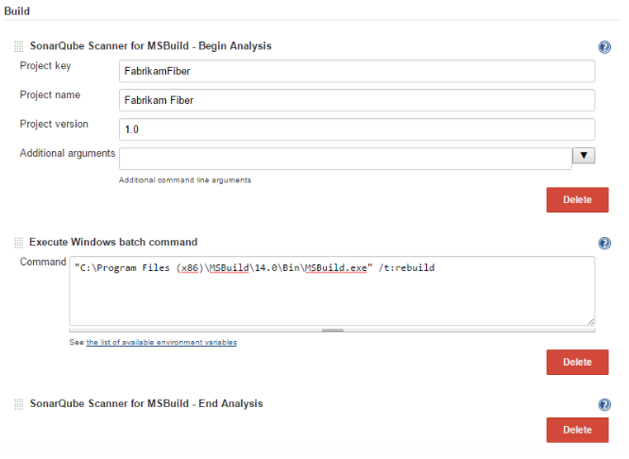

## **Analyzing in a Jenkins pipeline**

1. Since **version 2.5** of the SonarQube Scanner for Jenkins, there is an official support of Jenkins pipeline. We provide a 'withSonarQubeEnv' block that allow to select the SonarQube server you want to interact with. Connection details you have configured in Jenkins global configuration will be automatically passed to the scanner.

**SonarQube Scanner for MSBuild**

|  |
| --- |
| node {    stage('SCM') {      git '<https://github.com/foo/bar.git'>    }    stage('Build + SonarQube analysis') {      def sqScannerMsBuildHome = tool 'Scanner for MSBuild 2.2'      withSonarQubeEnv('My SonarQube Server') {        // Due to SONARMSBRU-307 value of sonar.host.url and credentials should be passed on command line        bat "${sqScannerMsBuildHome}\\SonarQube.Scanner.MSBuild.exe begin /k:myKey /n:myName /v:1.0 /d:sonar.host.url=%SONAR_HOST_URL% /d:sonar.login=%SONAR_AUTH_TOKEN%"        bat 'MSBuild.exe /t:Rebuild'        bat "${sqScannerMsBuildHome}\\SonarQube.Scanner.MSBuild.exe end"      }    }  } |

5. How to run sonar through command prompt?

<https://dzone.com/articles/how-quickly-get-started-sonar> - Link for the installation and running a project for analysis.

NOTE:

For Example: I have taken Tera_Adopt as my project. Do changes in the D:\sonar-runner-2.4\conf\sonar-runner.properties 🡪uncomment the fields as by-default all are commented 🡪 makes changes in

1. sonar.host.url=http://10.53.67.7:9110/
2. sonar.jdbc.url=jdbc:mysql://10.53.67.18:3306/sonar
3. sonar.jdbc.username=sonar
4. sonar.jdbc.password=sonar
5. sonar.login=admin
6. sonar.password=admin

vii)sonar.projectKey=Tera_Adopt

viii)sonar.projectName=Tera_Adopt

ix)sonar.projectVersion=1.0

x)sonar.sources=src

xi) sonar.language=java

7.) Sometimes we may get ERROR: Sonar Scanner executable is not found for sonar runner ?

Ans-Manage Jenkins 🡪 configure system 🡪Global properties 🡪Add Environment variables and its path

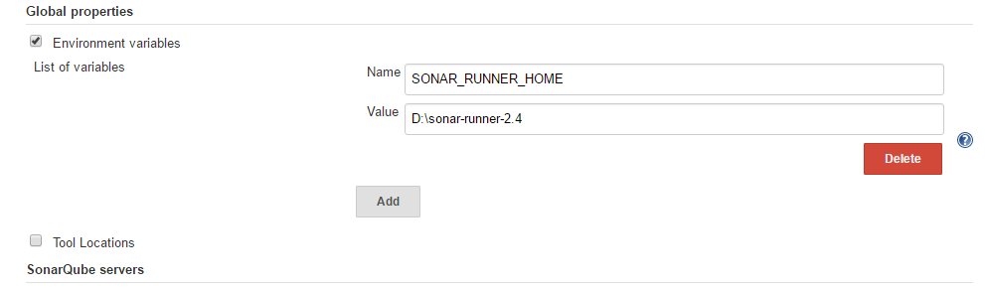

8. Why getting ERROR Execution Failure: java. lang. illegalstateException: unable to blame file while doing build for sonar analysis in Jenkins?

Ans-Give the base directory path correctly in sonar.properties in the job configuration for example as below –

sonar.projectKey=Tera_Adopt

sonar.projectName=Tera_Adopt

sonar.projectVersion=1.0

sonar.sources=src

sonar.language=java

sonar.login=admin

sonar.password=admin

sonar.projectBaseDir=..\\..\\job6\\workspace\\workspace\\QScheduler

sonar.host.url=http://10.53.67.7:9110

sonar.jdbc.url=jdbc:mysql://10.53.67.18:3306/sonar

<http://10.53.67.7:9110/> -SONARQUBE SERVER LINK